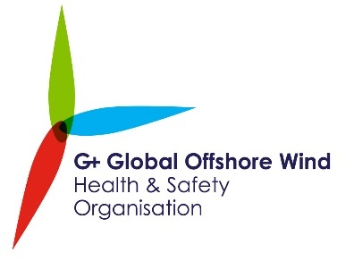

Media release
15 January 2020
Equinor safety head takes helm of offshore wind health & safety body
The G+ Global Offshore Wind Health and Safety Organisation has today announced Tove Lunde as its new Chair.
As Head of Safety, Security and Sustainability for New Energy Solutions at Equinor, Tove brings a wealth of experience from her current role supporting business development, project activities and operations for Equinor’s offshore wind, solar, hydrogen and CCUS activities.
A G+ board member for the past 2.5 years, Tove previously spent 17 years with ExxonMobil, before taking up roles in Equinor including Vice President of Modifications for their offshore installations portfolio and Head of Safety and Sustainability.
As the new Chair of G+, Tove will steer the organisation’s work around incident data reporting, good practice guidance and industry workshops, all helping to improve the health and safety of offshore farm workers around the world.
Louise Kingham OBE FEI, Chief Executive of the Energy Institute, which provides the secretariat for G+, commented:
“Since its inception, G+ has led the offshore wind industry’s endeavours to improve transparency and performance in health and safety.
“I’m delighted that Tove, with her vast industry experience, is stepping in to steer G+ as it continues to support the burgeoning global offshore wind sector”.
Tove Lunde said:
“I’m honored and humbled to take on the role of Chair of the G+, a knowledgeable and impactful organisation when it comes to shaping the health and safety standards in offshore wind.
“Together we aim to make the global industry safer and I look forward to leading this collaborative work”.
The G+ Offshore Wind Health and Safety Organisation, comprises of nine leading operators – EDF Renewables, EDPR, Equinor, Ørsted, RWE, ScottishPower Renewables, Siemens Gamesa, SSE, Vattenfall – as well as many associate members.
G+ will be holding their annual Stakeholder Day on Wednesday 12 February in Amsterdam, to discuss health and safety challenges facing the sector, as well as the group’s forward work programme. Industry experts interested in attending should contact: gplus@energyinst.org

Notes for editors
- For media enquiries and journalist accreditation, contact Neil Michie on 020 7467 7132 or nmichie@energyinst.org

- G+ is the global health and safety organisation for the offshore wind industry. The Energy Institute provides the secretariat and supports the ongoing work of the G+.
We bring together business leaders, health and safety experts and organisations operating in the offshore wind industry to drive good practice and promote world-class safety performance across the sector.
Through an evidence based approach, we ensure key emerging risks are mitigated through co-operation and shared learnings, aiming for the highest levels of health and safety standards being pursued throughout the life cycle of offshore wind farms.
We engage on important industry matters by facilitating discussion and bringing together industry stakeholders to speak with one voice for the offshore wind industry.

- The member companies of the G+ are: EDF Renewables, EDPR, Equinor, Ørsted, RWE, ScottishPower Renewables, Siemens Gamesa, SSE, Vattenfall.

- Associate members of the G+ are: Copenhagen Infrastructure Partners, ESB, GE, Macquarie/Green Investment Group, Maple Power, MHI Vestas, Shell, Transmission Investment and Van Oord.

- The Energy Institute (EI) is the chartered professional membership body bringing global energy expertise together.
We gather and share essential knowledge about energy, provide the skills that are helping us all use it more wisely, and develop the good practice needed to keep it safe and secure.
We articulate the voice of energy experts, taking the know-how of around 20,000 members and 200 companies from 120 countries to the heart of the public debate.
And we’re an independent, not-for-profit, safe space for evidence-based collaboration, an honest broker between industry, academia and policy makers.
The EI is here for anyone who wants to better understand or contribute to the extraordinary energy system on which we all depend.

